**Exercise No: 9**

**Date: 23-11-2020**

__________________________________________________________________________________

**AIM:** To perform various operations on dictionaries.

**LINK:**

<http://103.53.53.18/mod/hvp/view.php?id=329>

**OUTPUT:**

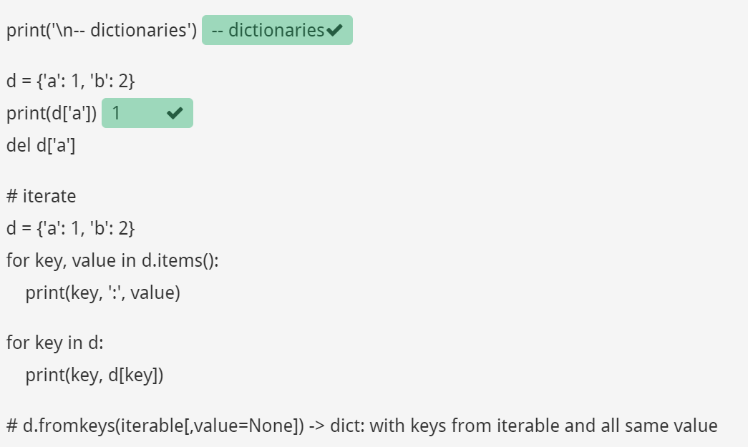

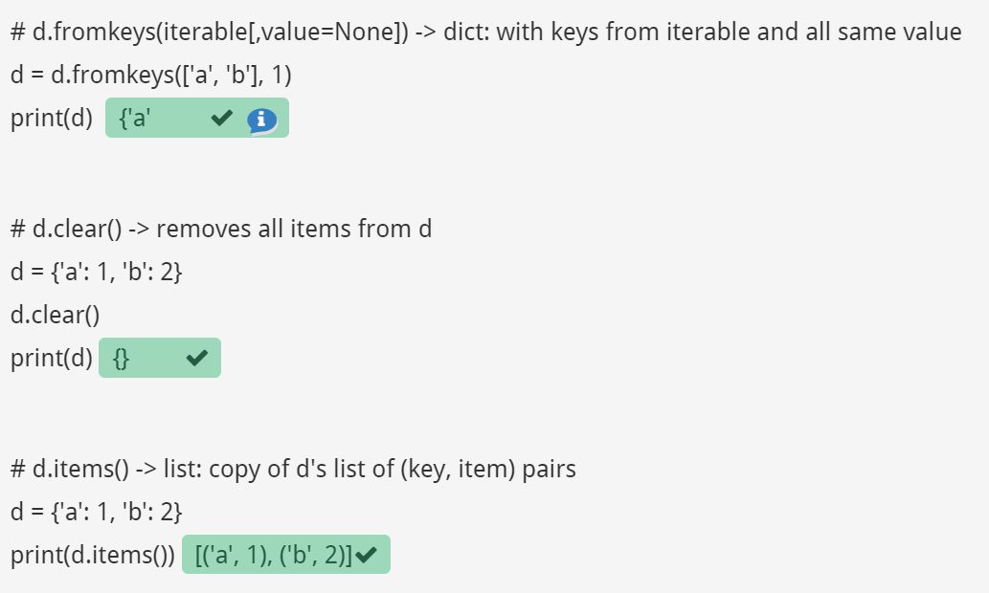

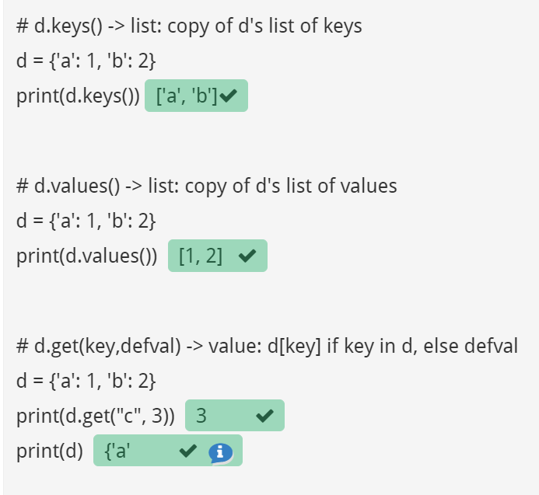

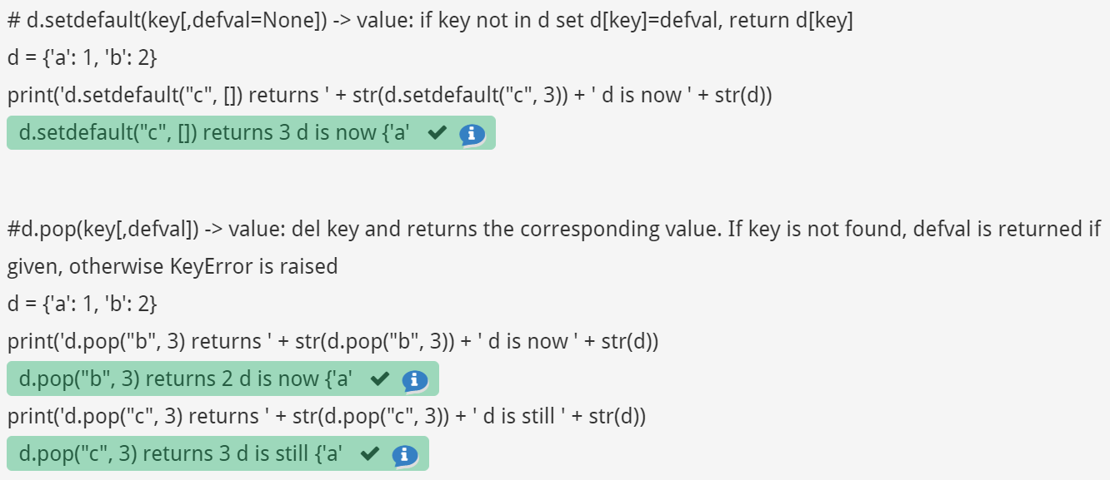

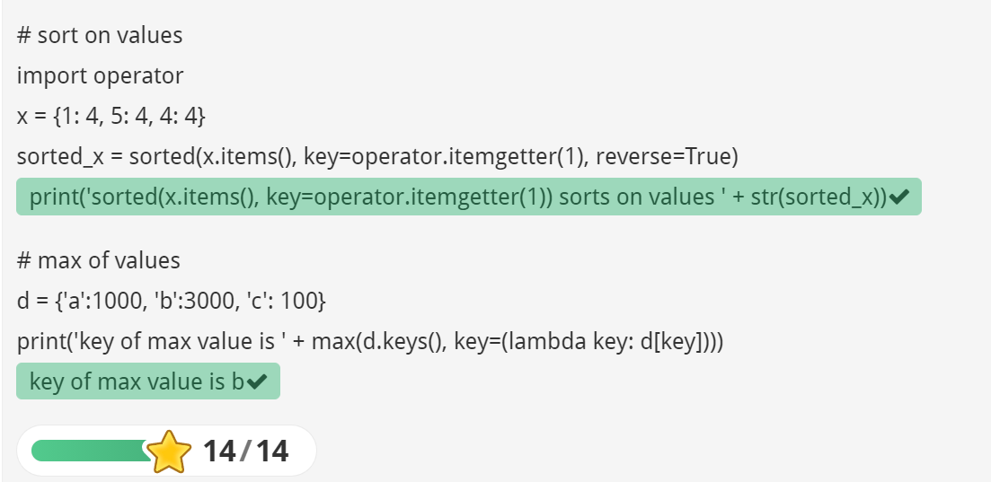

**RESULT:** Thus, various operations on dictionaries are executed.